Fan Performance Analysis

--the file owner is--

---address--

Wichaya, Jittawat, Research And Development Department

4 August 2017

**1.Executive Summary** **1**

**2. Background** **2**

**3. Experiment** **5**

3.1 Methods 5

**4. Results** **7**

**5. Discussion** **8**

5.1 Efficiency 8

5.1.1 Calculation methods and assumptions 8

5.1.2 Calculation results 9

5.2 Power Output 10

5.2.1 Indicators 10

5.2.2 Calculation Result 11

5.3 Consumption, Noise, and Heat 12

5.3.1 Indicators 12

5.3.2 Results 12

**6. Conclusion** **13**

**7. Reference** **13**

**8. Appendix** **13**

# 1.Executive Summary

----- executive summary----variable----

Fan performance are measured by several factors including efficiency, total output, electrical consumption, heat production , and noise. In this experiment we have tested 3 different specimens namely "18" Hatari curve Sample", 18" AS Hatari curve production", and "18" Deckerform curve sample"

The result clearly shows that the "18" Deckerform curve sample" is by far the best specimen in term of absolute output. Although, it has the lowest wind speed, which is caused by surface appearance and heavy weight.

The summary of the test results can be seen in fig 1.1 and 1.2.

|  |  |  |  |  |  |  |  |
| --- | --- | --- | --- | --- | --- | --- | --- |
| **Summary table** | | | | | | | |
|  | Revolution frequency (RPM) | Volumetric flow at 1 atm  (m3/min) | Max Wind Speed  (m/min) | Power Consumption  (Watt) | Air Kinetic Power output(Watt) | Efficiency | estimated heat production (Watt) |
| 18" Hatari curve Sample | 1050 | 79.07 | 200.55 | 60 | **3.68** | **6.13%** | 56.3 |
| 18" AS Hatari curve production | 1116 | 81.43 | 209.55 | 59.3 | **4.58** | **7.72%** | 54.7 |
| 18" Deckerform curve sample | 1042 | 94.21 | 185.95 | 59 | **4.03** | **6.83%** | 55.0 |

Fig 1.1 Summary of comparison table

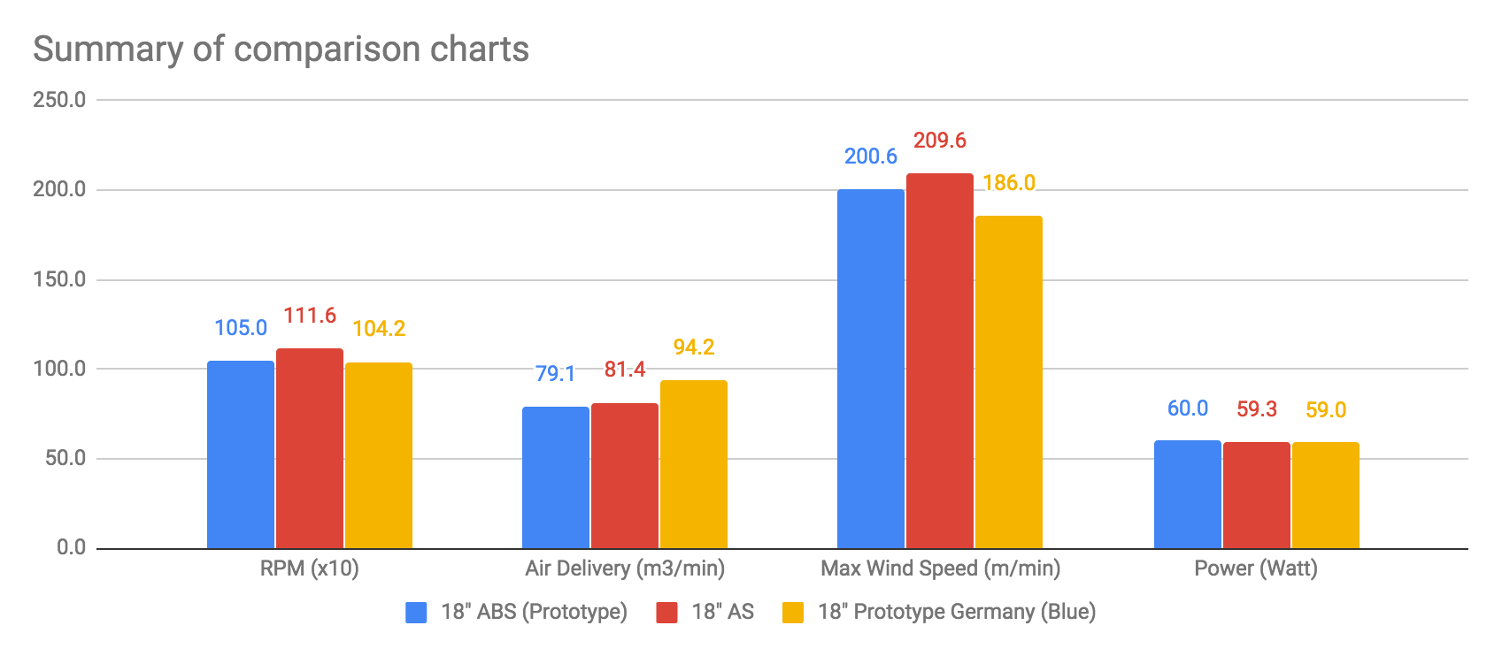

Fig 1.2 Summary of comparison charts

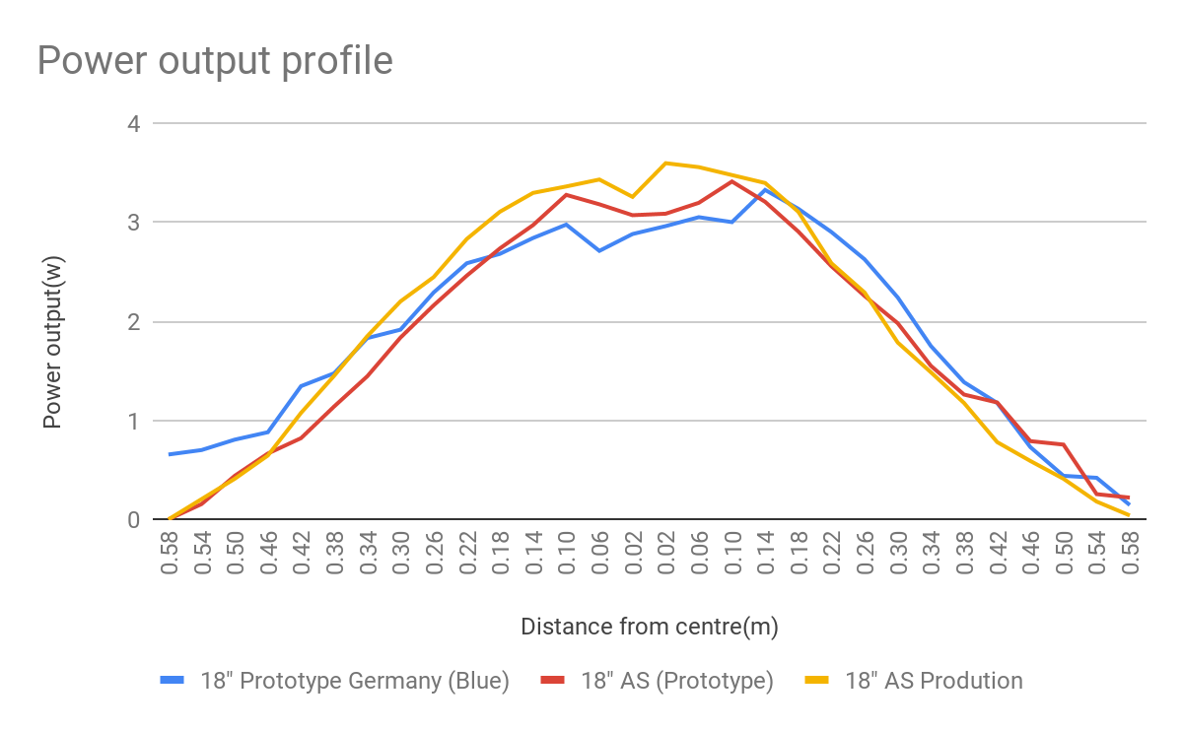

Fig1.3 Power output profile

# 2. Background

Fan is modelled as an energy converter with the purpose of converting electrical energy into kinetic energy. The purpose of a fan is to cool the subject by increasing the wind speed which in turn increase the heat transfer coefficient between air and the subject. The effect of wind speed is well studied and documented the relationship can be viewed in the referenced literature.[1][4]

## 2.1 The cooling effect of air

The effect of heat removal is modelled by Newton’s law of heat transfer (equation 2.1.1)

*q = hc A dT*

*where*

*q = heat transferred per unit time (W, Btu/hr)*

*A = heat transfer area of the surface (m2, ft2)*

*hc = convective heat transfer coefficient of the process (W/(m2K) or W/(m2oC), Btu/(ft2 h oF))*

*dT = temperature difference between the surface and the bulk fluid (K or oC, F)*

*Equation 2.1.1 Newton’s law of heat transfer*

# 

## 2.2 Kinetic energy

* The output of a fan is expressed as the rate of kinetic energy output of the fluid stream (usually air) This is calculated by the equation 2.2.1

Equation 2.2.1 Kinetic energy[6]



Fig 2.2.1 representation of relationship between radius and cross sectional area

* For a fan, we can assume that it is cylindrically symmetrical and is moving the fluid in only 1 direction resulting in a mass flow Equation 2.2.2

Equation 2.2.2 rate of mass flow

* The rate of kinetic energy output can be calculate by integrating the mass flow rate over all cross sectional area Equation 2.2.3

Equation 2.2.3 Rate of Kinetic energy generation

* Since the fan is radially symmetrical we are able to find the cross sectional area as a function of radius by Equation 2.2.4

r = radius

Equation 2.2.4 relationship between cross sectional area and radius

* Equation 2.2.5 can be used to calculate the total kinetic energy of the output air

Equation 2.2.3 the relationship between Kinetic energy generation rate and air velocity

* Efficiency can be calculated by dividing the rate of kinetic energy generation by the rate of electrical energy input

# 3. Experiment

The fan is set up in compliance with the standard IS 1555-1979 (India) and TIS 127-2536(Thailand).

## 3.1 Methods

* Test chamber is larger than 7.5x3.5x2.5 m. with no other electrical instruments in the room than the experiment tools
* Fan is more than 1.2m from the back wall and 6m from the from wall
* Anemometer has an inner diameter of 100mm
* The set up is shown in the (figure 3.1.1)
* Anemometer is read every 0.04m(**y**) from the centre at a distance of 1.35m(**x**) from the fan (figure 3.1.2)
* 2 sets of air velocity data were collected on each point as an average over the period of 2 minutes

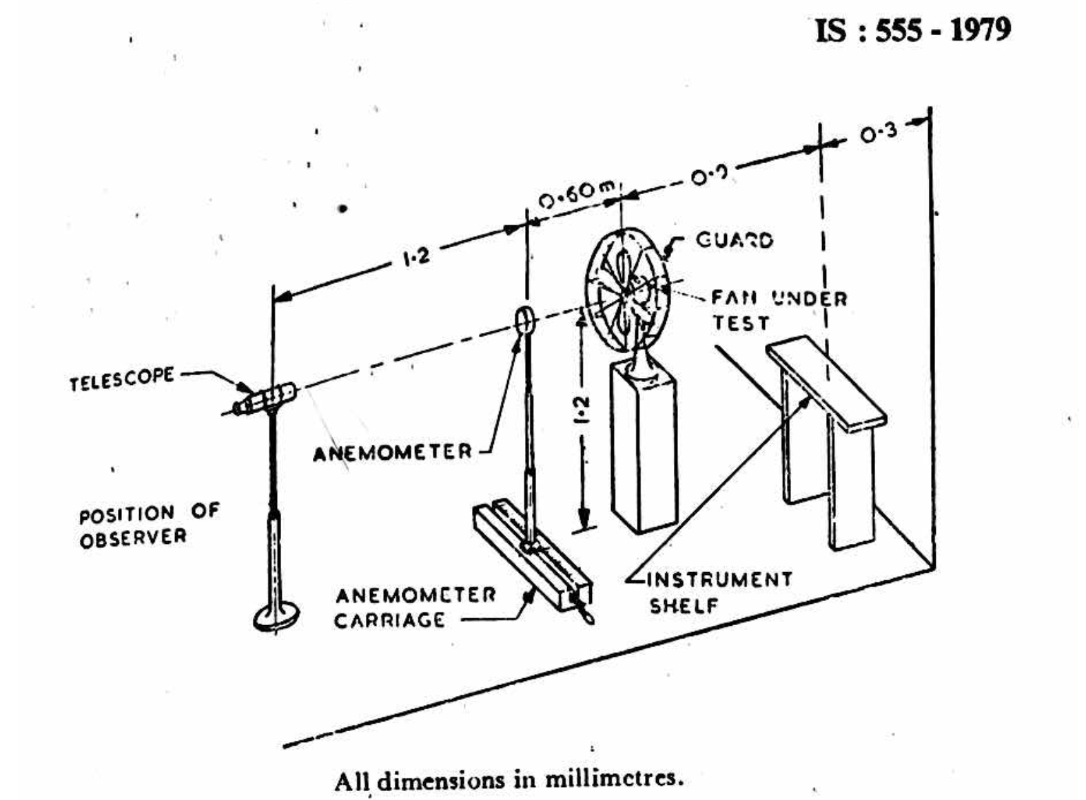

Fig 3.1.1 Experimental setup [1]

# 

Fig 3.1.2 Bird eye view of the experimental setup

# 

# 

# 

# 4. Results

Raw data collected in presented in fig 4.1

|  |  |  |  |  |  |  |  |
| --- | --- | --- | --- | --- | --- | --- | --- |
|  |  | Air Velocity Left (ms-1) | | | Air Velocity Right (ms-1) | | |
| Pos. | Dist. | 1st | 2nd | Avg. | 1st | 2nd | Avg. |
|  | (m) |  |  |  |  |
| 1 | 0.02 | 2.92 | 2.84 | 2.88 | 3.06 | 2.86 | 2.96 |
| 2 | 0.06 | 2.75 | 2.67 | 2.71 | 3.11 | 2.99 | 3.05 |
| 3 | 0.1 | 3.16 | 2.79 | 2.98 | 2.96 | 3.04 | 3.00 |
| 4 | 0.14 | 3.00 | 2.68 | 2.84 | 3.44 | 3.21 | 3.33 |
| 5 | 0.18 | 2.54 | 2.82 | 2.68 | 3.08 | 3.19 | 3.14 |
| 6 | 0.22 | 2.84 | 2.33 | 2.59 | 2.91 | 2.89 | 2.90 |
| 7 | 0.26 | 2.26 | 2.32 | 2.29 | 2.51 | 2.74 | 2.63 |
| 8 | 0.3 | 1.92 | 1.91 | 1.92 | 2.29 | 2.19 | 2.24 |
| 9 | 0.34 | 2.01 | 1.65 | 1.83 | 1.69 | 1.81 | 1.75 |
| 10 | 0.38 | 1.65 | 1.30 | 1.48 | 1.34 | 1.43 | 1.39 |
| 11 | 0.42 | 1.38 | 1.31 | 1.35 | 1.21 | 1.14 | 1.18 |
| 12 | 0.46 | 0.90 | 0.86 | 0.88 | 0.60 | 0.86 | 0.73 |
| 13 | 0.5 | 0.79 | 0.82 | 0.81 | 0.46 | 0.42 | 0.44 |
| 14 | 0.54 | 0.61 | 0.79 | 0.70 | 0.40 | 0.44 | 0.42 |
| 15 | 0.58 | 0.71 | 0.60 | 0.66 | 0.17 | 0.12 | 0.15 |

Figure 4.1 air velocity raw data

# 

# 5. Discussion

From the raw data, we are able to determine the performance measured by efficiency, total output, electrical consumption, heat production, and noise.

## 5.1 Efficiency

### 5.1.1 Calculation methods and assumptions

The efficiency of the fan is estimated based on the equation 5.1.1.1 The power output is estimated by the equation 5.1.1.2. We assume that the useful energy output is totally the air kinetic energy and the pressure in the test room is kept uniformly constant at 1 bar. The air composition is assumed to be 78% Nitrogen, 21% Oxygen, and 1% Argon.

Equation 5.1.1.1[appendix 8.1.4]

Equation 5.1.1.2 [appendix 8.1.1]

### 5.1.2 Calculation results

The result shows that the set “Hatari curve production” is the best performing set up with 7.72% efficiency compared to 6.83% by “DKF curve sample” and 6.13% by “Hatari curve sample”. The total Kinetic power output is also the Highest at 4.58W compared to 4.03W and 3.68 by both “DKF curve sample” and “Hatari curve sample”.

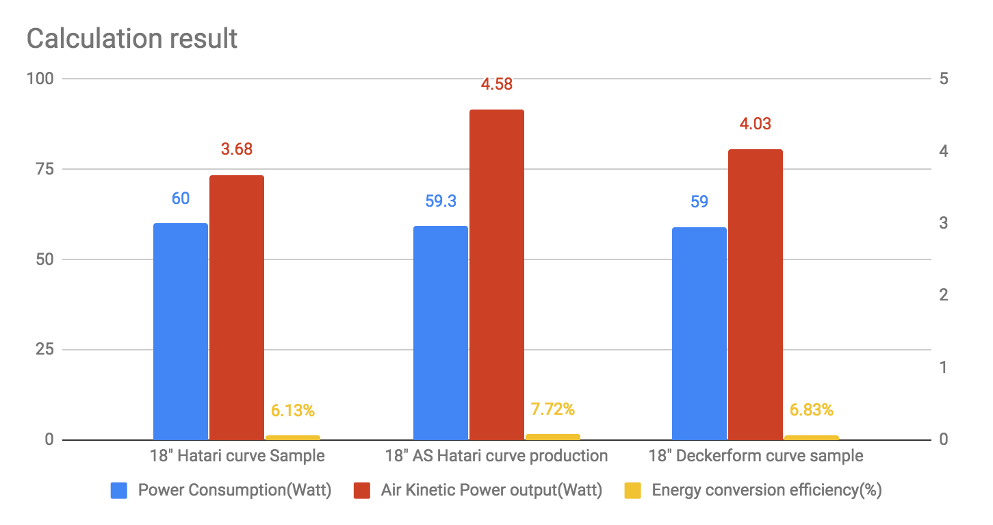

Figure 5.1.2.1 Efficiency comparison

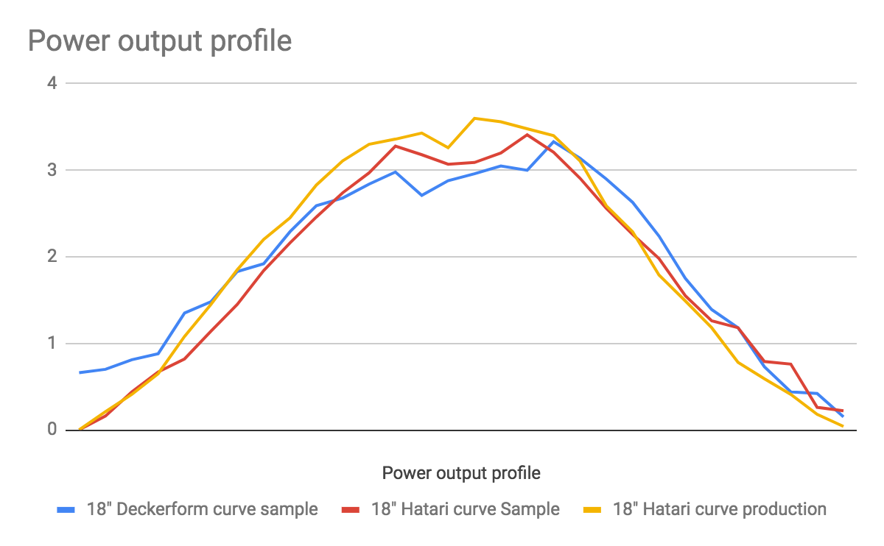

Figure 5.1.2.2 Output profile

## 5.2 Power Output

### 5.2.1 Indicators

* Peak velocity measures the group of air that has the most energy. This will get translated into air delivery at a longer range due to the effect of inducement and entrainment[2][3].
* Total Power output indicates the actual kinetic energy that is produced by the fan
* Volumetric flow rate, an easy indicator to calculate, however it is not a good indicator because the negligence of the inducement and entrainment effect. Useful for a pressure differential set up with ventilation fans.

### 5.2.2 Calculation Result

The power output of “Hatari curve production” is the highest with all 3 indicators pointing in the same direction while “Hatari1” and “Anchor” have similar output.

The power output of “Hatari curve production” is the highest with all 3 indicators pointing in the same direction while “Hatari1” and “Anchor” have similar output.

“Hatari curve production” is the best performing set up with 7.72% efficiency compared to 6.83% by “DKF curve sample” and 6.13% by “Hatari curve sample”. The total Kinetic power output is also the Highest at 4.58W compared to 4.03W and 3.68 by both “DKF curve sample” and “Hatari curve sample”

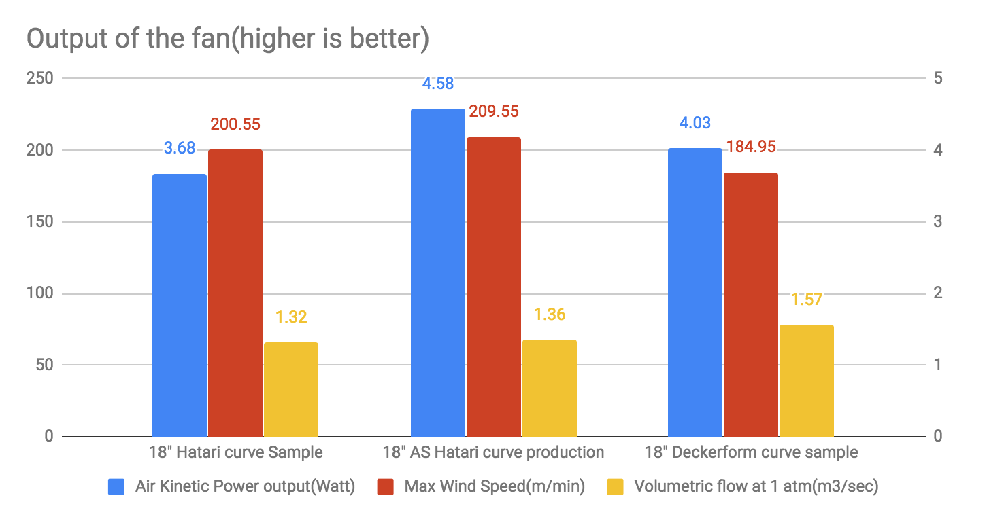

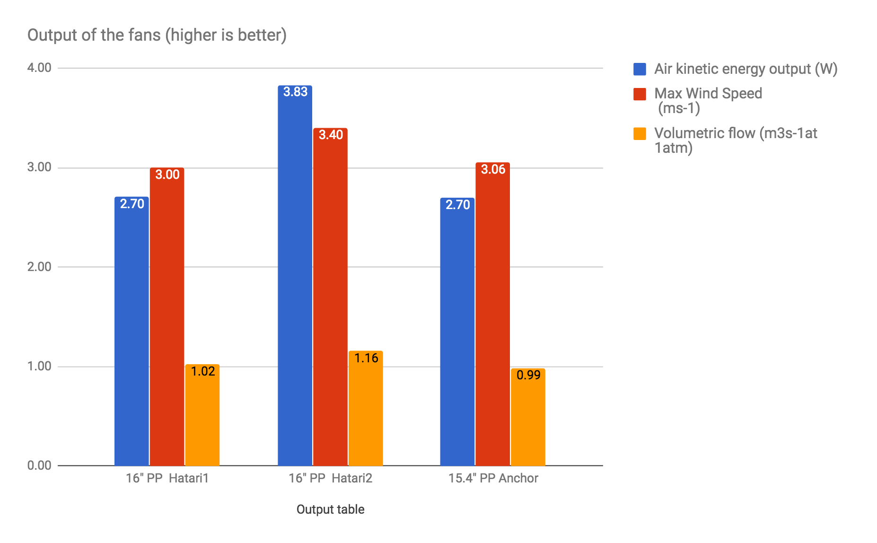

Figure 5.2.1 power output indicator

## 

## 

## 

## 

## 5.3 Consumption, Noise, and Heat

### 5.3.1 Indicators

* The energy which is not converted into useful kinetic energy are dissipated as heat in the motor, joints, and on the surface of the propellers. This can be calculated by subtracting the kinetic energy from the power input.[appendix 8.1.2]
* Energy consumption are measured directly by the current fed to the motor at 220V 50Hz
* Noise and heat have a weak correlation to the operating revolution frequency due to the friction factor on the blade. However, this may not be the best indicator.

### 5.3.2 Results

“Hatari2” has the highest electrical consumption and is producing the most heat however, it has a lower RPM than “Anchor” which indicates that the noise produced is likely to be at a lower frequency. “Anchor” in consuming the least amount of electricity but the high RPM could lead to high frequency noise and high friction loss on the propellers.

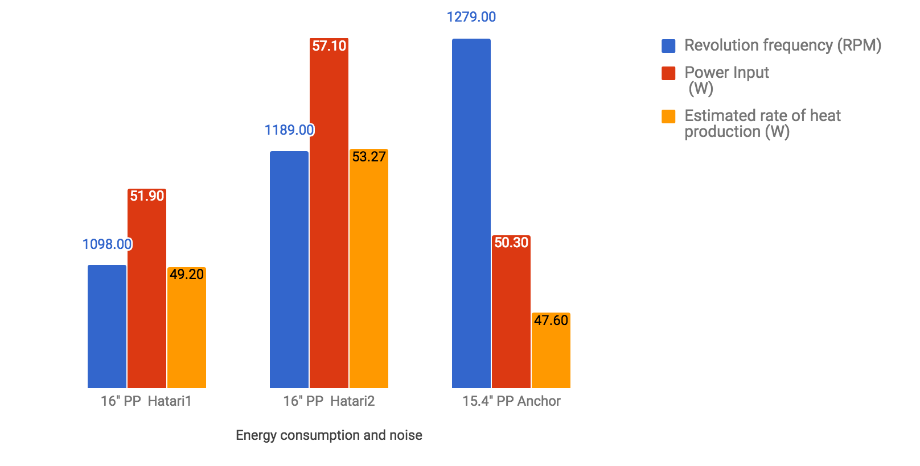

Figure 5.3.2.1 Consumption, noise, and heat

# 6. Conclusion

"16" PP MSS-0109-03 Hatari2" has the highest absolute output, efficiency and energy consumption of the three. The data is summarised in fig 6.1

|  |  |  |  |  |  |  |  |
| --- | --- | --- | --- | --- | --- | --- | --- |
| Summary table | | | | | | | |
|  | Revolution frequency (RPM) | Volumetric flow (m3s-1at 1atm) | Max Wind Speed  (ms-1) | Power Input  (W) | Air kinetic energy output (W) | Energy conversion  Efficiency (%) | Estimated rate of heat production (W) |
| 16" PP  Hatari1 | 1098.00 | 1.02 | 3.00 | 51.90 | 2.70 | 5.21 | 49.20 |
| 16" PP  Hatari2 | 1189.00 | 1.16 | 3.40 | 57.10 | 3.83 | 6.71 | 53.27 |
| 15.4" PP  Anchor | 1279.00 | 0.99 | 3.06 | 50.30 | 2.70 | 5.36 | 47.60 |

Fig 6.1 Summary of data

# 7.Reference

1. http://www.ijetae.com/files/Volume2Issue9/IJETAE_0912_80.pdf

2. M Bennett, M F Schatz, H Rockwood, and K Wiesenfeld, Proc. Roy. Soc. Lond. A 458 (2002) 563-579.

3. Strickland, J., & Chandler, N. (n.d.). HowStuffWorks "How the Dyson Bladeless Fan Works". HowStuffWorks. Retrieved May 27, 2014, from http://electronics.howstuffworks.com/gadgets/home/dyson-bladeless-fan.htm

4. <http://www.engineeringtoolbox.com/convective-heat-transfer-d_430.html>

5. <http://hyperphysics.phy-astr.gsu.edu/hbase/pber.html>

6. Jain, Mahesh C. (2009). [*Textbook of Engineering Physics (Part I)*](https://books.google.com/books?id=DqZlU3RJTywC). p. 9. [ISBN](https://en.wikipedia.org/wiki/International_Standard_Book_Number) [81-203-3862-6](https://en.wikipedia.org/wiki/Special:BookSources/81-203-3862-6)., [Chapter 1, p. 9](https://books.google.com/books?id=DqZlU3RJTywC&pg=PA9)

# 

# 8Appendix

## 8.1Efficiency calculation

## 8.1.1 Kinetic energy output

* The output of a fan is expressed as the rate of kinetic energy output of the fluid stream (usually air) This is calculated by the equation 2.2.1

Equation 2.2.1 Kinetic energy



Fig 2.2.1 representation of relationship between radius and cross sectional area

* For a fan, we can assume that it is cylindrically symmetrical and is moving the fluid in only 1 direction resulting in a mass flow Equation 2.2.2

Equation 2.2.2 rate of mass flow

* The rate of kinetic energy output can be calculate by integrating the mass flow rate over all cross sectional area Equation 2.2.3

Equation 2.2.3 Rate of Kinetic energy generation

* Since the fan is radially symmetrical we are able to find the cross sectional area as a function of radius by Equation 2.2.4

r = radius

Equation 2.2.4 relationship between cross sectional area and radius

* Equation 2.2.5 can be used to calculate the total kinetic energy of the output air

Equation 2.2.3 the relationship between Kinetic energy generation rate and air velocity

* Efficiency can be calculated by dividing the rate of kinetic energy generation by the rate of electrical energy input

## 8.1.2 Non-useful energy

The part of energy that is not useful is described by the equation 8.1.2.1 using bernoulli equation and the conservation of energy.

Equation 8.1.2.1 heat generation

In this experiment, there is no other forms of energy output than Kinetic energy and heat therefore the term non-heat energy output = 0

## 8.1.3 Bernoulli equation

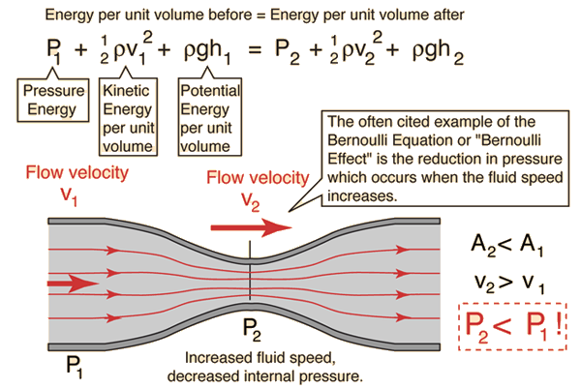

Bernoulli equation explaining the conservation of energy[5]

## 8.1.4 Efficiency